

# LAB – FILE

**Graphics and Animation Tools - Lab**

**CSGG 4101**

Name – Rishank Gupta

Roll No. – R100217062

Sap id – 500062486

Course – B. Tech CSE-OSS

Batch – 2

*Under the guidance of…*

Dr.Durgansh Sharma

Associate professor

Department of Cybernetics

School of computer Science (Socs)

**Experiment- 7**

**Aim: - Design of 3D Rocket using Blender.**

**Steps for designing the Rocket**

**Step-1:** Open Blender

**Step-2:** Create a blank file and delete the default cube.

**Step-3:** Press Shift+ A to open Mesh, and select a circle, and also take a similar smaller circle.

**Step-4:** Loft the 2 circles to make a 3-D transition.

**Step-5:** Duplicate the 3-D transition 3 times to make the tail of the rocket.

**Step-6:** Take a circle on z-axis, and a smaller circle about the length of the rocket’s body.

**Step-7:** Take a single center point on the top of the rocket in accordance with the height of the body.

**Step-8:** Now take the point and the 2 circles and apply loft of the total figure to make the body of the rocket.

**Step-9:** To make the fin of the rocket, extrude the surface using the points that are at symmetric distance from the body of the rocket.

**Step-10:** Select material, and add base color, eventually assigning the particular material and base color to the object.

**Step-11:** Now add a camera and a light source to it. And arrange the camera to the best fit view.

**OUTPUT SCREEN:**

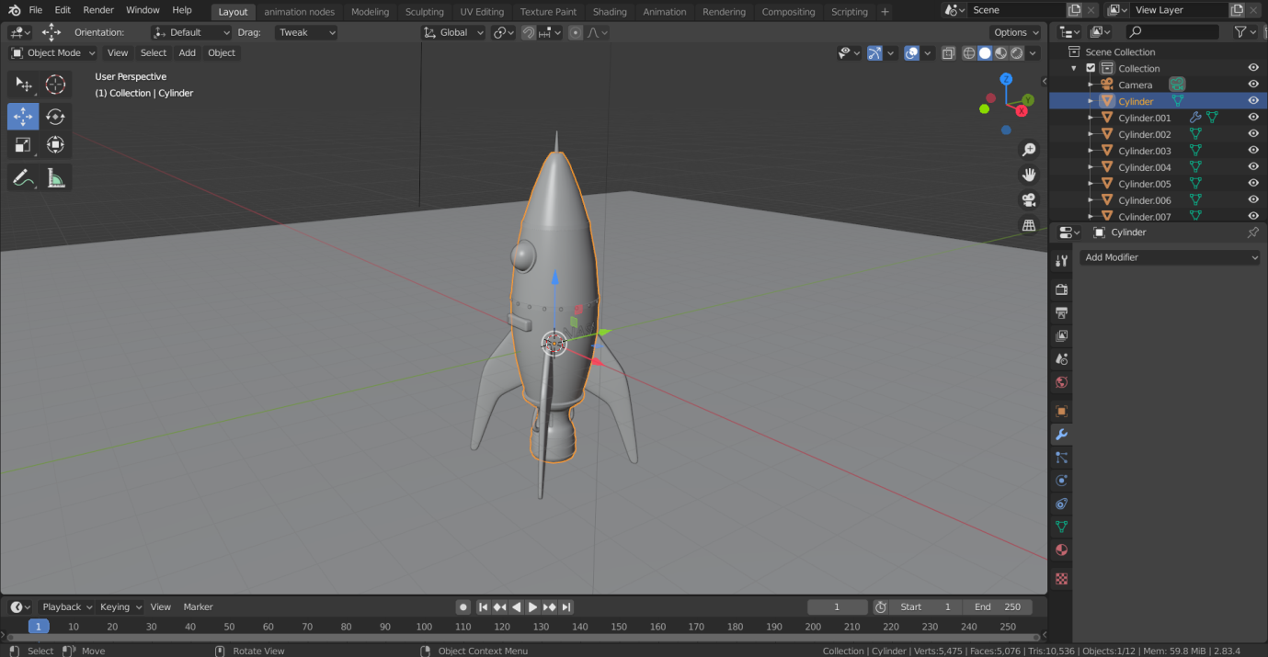

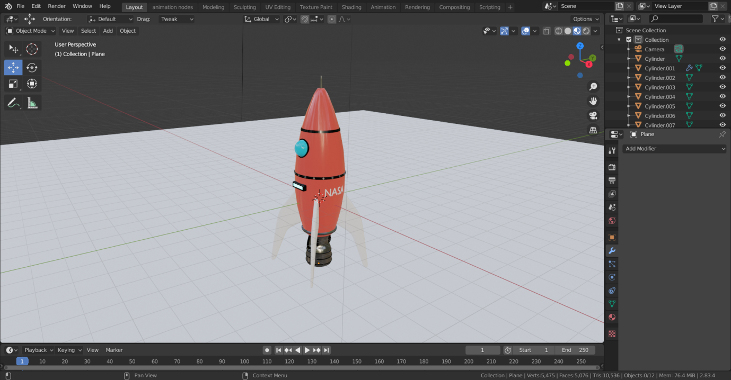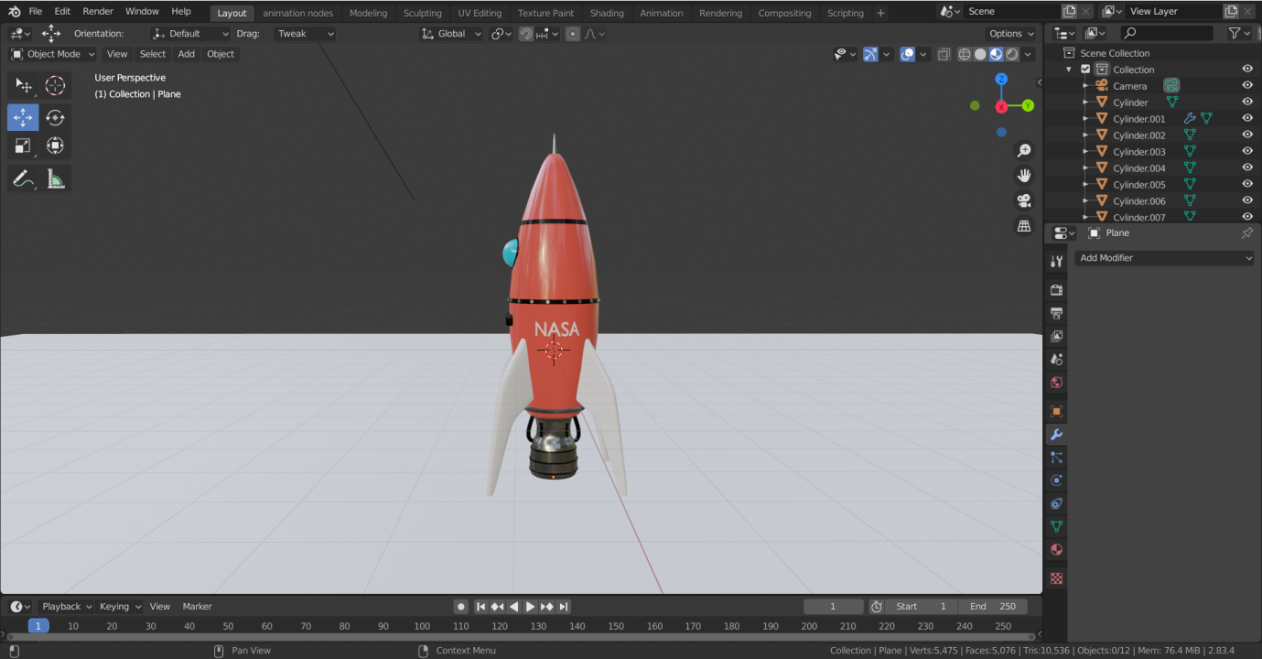

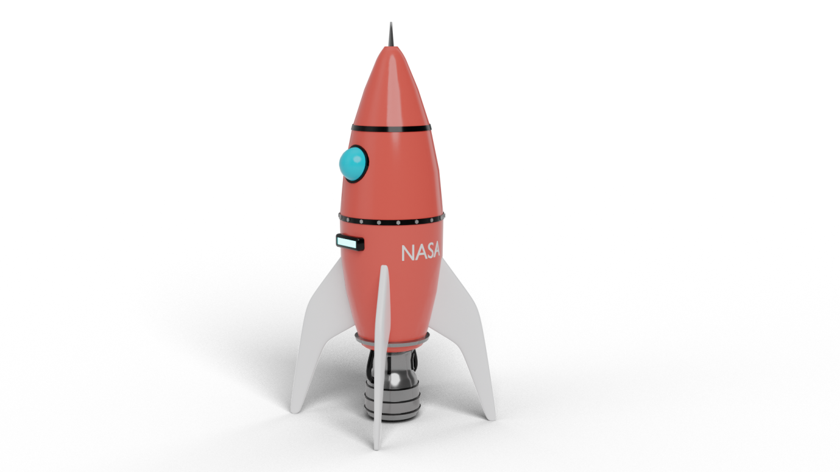

**Link:**[**https://drive.google.com/drive/folders/1UunydRTsn_AphDvleyGCrQaQ-t4LqZZt?usp=sharing**](https://drive.google.com/drive/folders/1UunydRTsn_AphDvleyGCrQaQ-t4LqZZt?usp=sharing)